Equatoguinean delegation at INDABA 2017 International Tourism FairThe Inkosi Albert Luthuli International Convention Centre in Durban, capital of the South African province of KwaZulu-Natal, was the setting from 16th to 18th May for the 2017 edition of the INDABA International Tourism Fair.
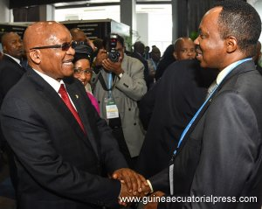
H. E. Jacob Zuma just before the opening
of the fair.
Click image to enlarge
and see the rest of the photographs
24/05/2017
The largest South African tourism fair was attended by two representatives from the Republic of Equatorial Guinea Ministry for Tourism, Mahua Bendje Ngongolo and Ernesto-Martín Cayetano Andeme.
INDABA 2017 was opened by the President, H. E. Jacob Zuma, in the presence of the host, the Minister for Tourism, Tokozile Xasa, and before more than six hundred accredited media organisations, at the DURBAN ICC (Durban International Conference Centre).
In his speech, the minister highlighted the importance of tourism for the economies of African countries, with respect to the generation of wealth, and thus employment, together with its contribution towards achieving "the eradication of poverty from our continent".
Thanks to its 35-year history, INDABA is a benchmark with respect to tourism on the African continent. With over 7,000 visitors, including tour operators, travel agencies, hotel chains and other professionals, from 18 African countries and the rest of the world, Durban was, for three days, the capital of world tourism.
The significant presence of countries from Southern Africa, such as Tanzania, Madagascar, Rwanda, Kenya, Malawi, Zimbabwe or Lesotho is worth pointing out.
The Equatoguinean delegation held important meetings with tour operators, travel agencies, hotel chains and other companies from the sector interested in the Equatoguinean market as a tourist destination.
Text and photos: Ministry for Tourism Office.
Equatorial Guinea Press and Information Office

